Lab Exercise - Create an Ubuntu Azure Virtual Machines from Your Laptop Using Terraform

Objective
In this lab, you will:
- Install Azure CLI on laptop
- Authenticate with Microsoft Azure
- Configure Terraform authentication
- Create Ubuntu VM from laptop
- Connect to VM
- Destroy infrastructure

Prerequisites
Install:
- Terraform
- Azure CLI
- SSH client

Step 1: Install Azure CLI
Download Azure CLI:
Azure CLI Download
Verify installation:
az version

Step 2: Login to Azure
Open terminal on laptop.
Run:
az login

Browser opens for authentication.
After login, verify account:
az account show

Step 3: Create Project Folder
mkdir terraform-azure-vm
cd terraform-azure-vm

Step 8: Generate SSH Keys
Linux/macOS
ssh-keygen

Keys created in:
~/.ssh/id_rsa
~/.ssh/id_rsa.pub

Step 9: Create Terraform File
Create:
main.tf

Step 10: Paste Terraform Code
terraform {
required_providers {
azurerm = {
source = "hashicorp/azurerm"
version = "~>3.0"
}
}
}
provider "azurerm" {
features {}
}
resource "azurerm_resource_group" "rg" {
name = "terraform-rg"
location = "East US"
}
resource "azurerm_virtual_network" "vnet" {
name = "terraform-vnet"
address_space = ["10.0.0.0/16"]
location = azurerm_resource_group.rg.location
resource_group_name = azurerm_resource_group.rg.name
}
resource "azurerm_subnet" "subnet" {
name = "terraform-subnet"
resource_group_name = azurerm_resource_group.rg.name
virtual_network_name = azurerm_virtual_network.vnet.name
address_prefixes = ["10.0.1.0/24"]
}
resource "azurerm_public_ip" "pip" {
name = "terraform-pip"
location = azurerm_resource_group.rg.location
resource_group_name = azurerm_resource_group.rg.name
allocation_method = "Dynamic"
}
resource "azurerm_network_security_group" "nsg" {
name = "terraform-nsg"
location = azurerm_resource_group.rg.location
resource_group_name = azurerm_resource_group.rg.name
security_rule {
name = "SSH"
priority = 1001
direction = "Inbound"
access = "Allow"
protocol = "Tcp"
source_port_range = "*"
destination_port_range = "22"
source_address_prefix = "*"
destination_address_prefix = "*"
}
}
resource "azurerm_network_interface" "nic" {
name = "terraform-nic"
location = azurerm_resource_group.rg.location
resource_group_name = azurerm_resource_group.rg.name
ip_configuration {
name = "internal"
subnet_id = azurerm_subnet.subnet.id
private_ip_address_allocation = "Dynamic"
public_ip_address_id = azurerm_public_ip.pip.id
}
}
resource "azurerm_network_interface_security_group_association" "assoc" {
network_interface_id = azurerm_network_interface.nic.id
network_security_group_id = azurerm_network_security_group.nsg.id
}
resource "azurerm_linux_virtual_machine" "vm" {
name = "ubuntu-vm"
resource_group_name = azurerm_resource_group.rg.name
location = azurerm_resource_group.rg.location
size = "Standard_B1s"
admin_username = "azureuser"
network_interface_ids = [
azurerm_network_interface.nic.id,
]
admin_ssh_key {
username = "azureuser"
public_key = file("~/.ssh/id_rsa.pub")
}
os_disk {
caching = "ReadWrite"
storage_account_type = "Standard_LRS"
}
source_image_reference {
publisher = "Canonical"
offer = "0001-com-ubuntu-server-focal"
sku = "20_04-lts-gen2"
version = "latest"
}
disable_password_authentication = true
}

Step 11: Initialize Terraform
terraform init

Step 12: Validate File
terraform validate

Step 13: Preview Resources
terraform plan

Step 14: Create VM
terraform apply -auto-approve

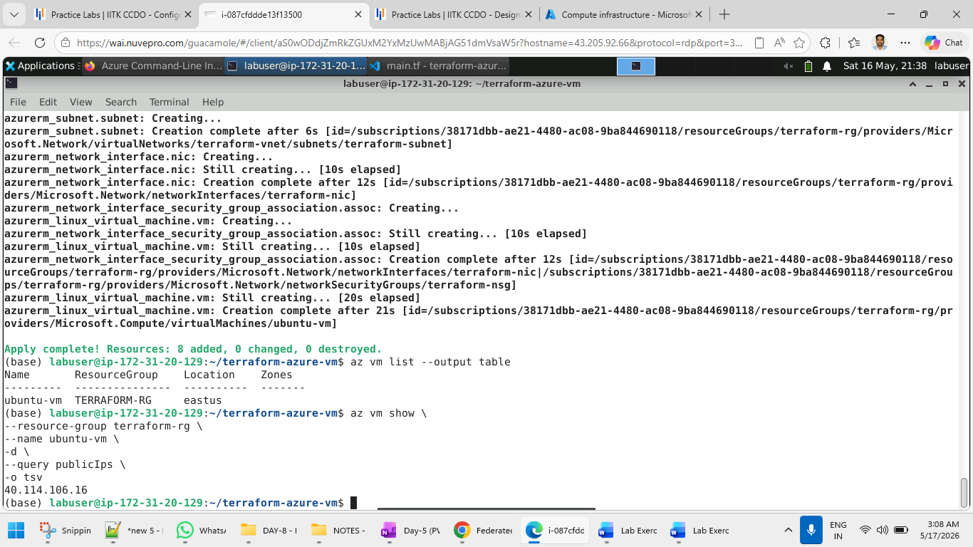

Step 15: Verify VM
az vm list --output table

Step 16: Get Public IP
az vm show \
--resource-group terraform-rg \
--name ubuntu-vm \
-d \
--query publicIps \
-o tsv

Step 17: Connect to VM
ssh azureuser@PUBLIC_IP

Step 18: Verify Ubuntu VM
Inside VM:
hostname

Check OS:
cat /etc/os-release

Step 19: Destroy Infrastructure
terraform destroy
Type:
yes

Important Files Created
File | Purpose
main.tf | Terraform configuration
terraform.tfstate | Terraform state
id_rsa | Private SSH key
id_rsa.pub | Public SSH key

